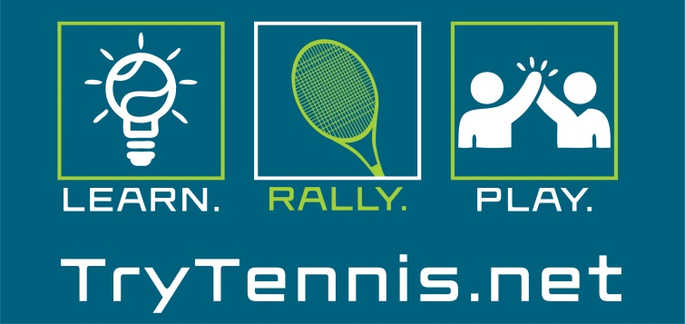

Try Tennis Curriculum
“Try Tennis” is a program created to introduce adults to the sport of tennis in a fun, social environment. Players will participate in a wide range of fun drills, games, and supervised play. The focus of the curriculum is to get participants playing as quickly as possible while not dwelling on precise technique. Your job as the instructor is to keep participants engaged and motivated throughout the process.
Please use the curriculum guide below as an outline for your Try Tennis Program. REMINDER: Some players may develop more quickly than others. Use your discretion when it comes to ball color and feel free to keep players on the 60 foot court if they have not quite caught on, yet.

Overview of Classes
All classes will be an hour and a half with two different sections. Part 1 of each class will be instruction based (approx. 45 mins). Part 2 of the class will be “supervised play” to put newly learned skills into action (approx. 45 minutes). At the conclusion of every class give your students some type of homework or something they can work on throughout the week leading up to the next class.
Class 1: Groundstroke Introduction
Class 2: Groundstroke continuation and Serve Introduction
Class 3: Review Groundstrokes and Serve
Class 4: Full court review and Volleys
Class 5: Tying it all together and Scoring Overview
Class 6: Supervised Round Robin/Tournament (This should be FUN; not too competitive. You should include: Food, Drink, & Music.)
Class 1
Equipment Needed: Orange Low Compression Balls, all activities done from service line and in
Goal of Lesson: Assess ability level of participants and introduce the forehand and backhand

Breakdown of Class 1
Instruction (45 mins- 1 hour)
- Welcome Group and explain format of lessons

- Warm-up and skill assessment

- Explanation and Introduction of Forehand

- Interactive Forehand Drills (correct feeding is crucial/teach them how)

- Explanation and Introduction of Backhands

- Interactive Backhand Drills

Game Play (30- 45 mins)
- For class 1 all play will be done from the service line and using orange balls

- Live ball games with modifications to allow players to have success.

  - Modifications include (number of bounces, how many players per team, tossing/throwing instead of hitting, etc.)

NOTES: Emphasize moving & tracking. These are the most important skills needed to rally. Also, mention the importance of them trying to practice some at home or possibly meet up with someone in class. The more they practice the easier it will be for them to progress.

Class 2
Equipment Needed: Orange Low Compression Balls, all activities done from 60’ and in
Goal of Lesson: Continue to work on groundstrokes and introduce serve

Breakdown of Class 2
Instruction (45 mins- 1 hour)
- Warm-up (ball skills)

- Review/Explanation of Forehand and Backhand

- Interactive Forehand drills

- Interactive Backhand drills

- Drills combining forehand and backhand

- Introduction/Explanation of Serve

- Serving drills (from service line or 60’ foot)

Game Play (30-45 mins)
- All games will use orange ball and be played from 60’ or closer

- Use a combination of games that will allow players to use both forehand and backhand.

- Allow students 1-2 chances to put the ball in play with a feed to get used to starting the point

NOTES: Spend a big chunk of time on the serve. Players need to be able to get the ball in play ASAP to start a point. The serve along with the return are the two most important shots in tennis. Be creative as the serve can be a boring stroke to teach!

Class 3
Equipment Needed: Green dot balls, full court
Goal of Lesson: Continue to work on groundstrokes and serve

Breakdown of Class 3
Instruction (45 mins- 1 hour)
- Warm-up (ball skills)

- Review/Explanation of Serve

- Serving drills

- Review/Explanation of Forehand and Backhand

- Interactive Forehand drills w/ rallying (quicker than pervious lessons)

- Interactive Backhand drills w/ rallying (quicker than previous lessons)

- Drills combining forehand and backhand w/ rallying

Game Play (30-45 mins)
- All games will use green ball and be played using full court (Make sure to explain the difference in balls bounce and stress movement & position)

- Use a combination of games that will allow players to use both forehand and backhand.

- Allow students 1-2 chances to put the ball in play with a feed to get used to starting the point

NOTES: If players aren’t ready to do drills with the green ball, feel free to use orange or modify however you see fit.

Class 4
Equipment Needed: Green dot balls for games, yellow balls for drills, full court
Goal of Lesson: Full court review, introduction of volleys, and yellow ball

Breakdown of Class 4
Instruction (45 mins- 1 hour)
- Warm-up (ball skills) By Class 4, participants should be able to rally some, possibly warm up and rally with orange ball before going back to green.

- Drills combining forehand and backhand w/ rallying

- Review/Explanation of Serve

- Serving drills

- Introduction and explanation of volleys

- Forehand and Backhand Volley Drills

Game Play (30-45 mins)
- All games will use green ball and be played using full court

- Introduce doubles formation and play points out of this formation

- Allow students 1-2 chances to put the ball in play with a feed to get used to starting the point

Class 5
Equipment Needed: Yellow ball, full court
Goal of Lesson: Full court review + volleys, scoring introduction, and intro to yellow ball

Breakdown of Class 5
Instruction (30-45 mins)
- Warm-up (ball skills)

- Scoring Introduction, overview or rules, and match play guidelines

- Drills covering full court play

- Serving drills

Game Play (45 mins-1 hour)
- All games will use yellow ball and be played using full court(If players are still struggling you can use green or orange ball)

- Have players play mini matches to review scoring and rules

- Mini matches can still use modified formats if necessary

- Play both singles and doubles

NOTES for next week (WEEK 6): Their last class will be the round-robin tournament. Feel free to set this up depending on how much they have progressed. You can get creative and do different color balls & courts while incorporating a team format. Try to have both singles and doubles options. Again, it should be FUN and not super competitive. We encourage you to invite representatives from your Community Tennis Association to talk about future programming in your local area.

